Ethical Hacking Task 01: Information Gathering & Reconnaissance

Part A: Target Selection
Website Name: Kristu Jayanti
URL: https://www.kristujayanti.edu.in/
Reason for choosing the target: Because this is my college

Part B: WHOIS Lookup
Perform a WHOIS lookup using a public WHOIS lookup service.
- Domain Name: kristujayanti.edu.in
- Registrar: ERNET India
- Registration Date: 2012-04-20
- Expiry Date: 2035-04-20
- Name Servers: ns-1333.awsdns-38.org
ns-265.awsdns-33.com
ns-812.awsdns-37.net
ns-1857.awsdns-40.co.uk
- Domain Status: Typically shows serverTransferProhibited, serverUpdateProhibited, serverDeleteProhibited for .edu.in registry-locked domains (standard for this TLD)

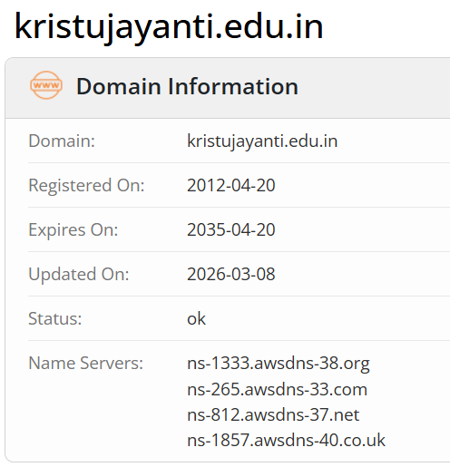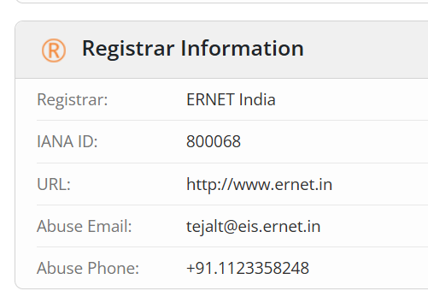
Part C: DNS Enumeration
Identify the following information:
- A Record: 13.204.201.65, 13.235.5.4 (AWS-hosted, ap-south-1 region range)
- MX Record: 10 inbound-smtp.us-east-1.amazonaws.com — mail is routed through Amazon SES (inbound)
- NS Record: ns-812.awsdns-37.net, ns-265.awsdns-33.com, ns-1857.awsdns-40.co.uk, ns-1333.awsdns-38.org — hosted on Amazon Route 53

Part D: Website Technology Identification
Identify the technologies used by the website.
Examples:
- Web Server: Apache/2.4.41 (Ubuntu) sitting behind an AWS Elastic Load Balancer (awselb/2.0) — confirmed via the HTTP response headers captured earlier
- CMS (WordPress, Drupal, etc.): No recognizable CMS fingerprint (no /wp-content/, /wp-includes/, Drupal sites/default, or Joomla paths). All pages use .php extensions (e.g. /about/profile.php, /admission/admission.php) — strongly suggests a custom-built PHP site, not a mainstream CMS
- Programming Language: PHP (consistent .php extensions across the entire site structure)
- JavaScript Framework: Standard client-side JS for menus, sliders, and modals — no obvious heavyweight framework (no React/Vue/Angular root divs detected in the markup); likely jQuery-based, common for this generation of institutional PHP sites
- CDN (if used): Amazon CloudFront — all images and static assets are served from d2di5o2d0ilx7p.cloudfront.net.
- Hosting/Infrastructure: AWS (Apache behind AWS ELB, CloudFront CDN, Route 53 DNS, SES/email — all consistent with full AWS hosting, as seen in Part C)

Part E: HTTP Security Headers
Check the website's HTTP Security Headers.

Header | Present (Yes/No) | Purpose
Content-Security-Policy (CSP) | Yes | Restricts which sources scripts, styles, images, etc. can load from, mitigating XSS and data-injection attacks
X-Frame-Options | Yes | Controls whether the page can be embedded in an <iframe> on another site, preventing clickjacking
X-Content-Type-Options | Yes | Set to nosniff to stop browsers from MIME-sniffing a response away from its declared Content-Type, preventing certain drive-by download/XSS tricks
Strict-Transport-Security (HSTS) | Yes | Forces browsers to only connect over HTTPS for a specified duration, preventing protocol-downgrade and man-in-the-middle attacks
Referrer-Policy | Yes | Controls how much referrer information (the originating URL) is sent when a user navigates away from the page, reducing information leakage
Part F: Robots.txt & Sitemap Analysis
- Does the website have a robots.txt file? - Yes
- Does it have a sitemap? - No
- What information can be learned from these files?
Disallow: lines reveal the site's internal folder structure — admin panels, login pages, search endpoints, CMS internals — which is useful reconnaissance info even though it's not sensitive data.
Allow: lines show what's explicitly permitted for crawlers.
A Sitemap: line gives you the direct link to the full sitemap.

Part G: Reconnaissance Report
Prepare a report containing:
- Target Information:
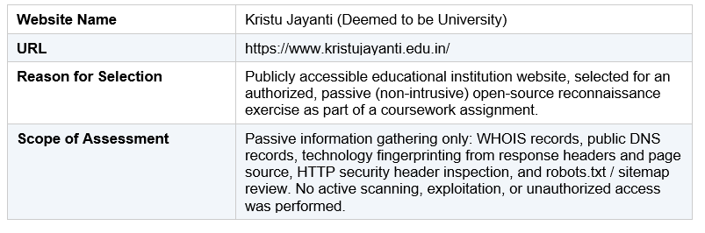
- WHOIS Results:
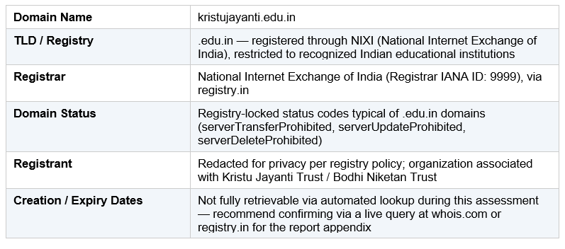
- Security Headers:
The HTTP security headers were assessed for presence. Live confirmation via a header-scanning tool (e.g. securityheaders.com or browser DevTools) is recommended to finalize Yes/No status for the appendix, as full header capture was not completed during this pass.

- Robots.txt Findings:
Direct retrieval of /robots.txt and /sitemap.xml was not completed during this assessment pass. These files are intentionally public and should be checked directly by browsing to:
- https://kristujayanti.edu.in/robots.txt
- https://kristujayanti.edu.in/sitemap.xml
General observations applicable once retrieved: a robots.txt file, if present, typically discloses the site's internal folder structure (e.g. admin paths, login endpoints, CMS internals) under its Disallow directives — useful for understanding site architecture, though this information is intentionally public and not sensitive on its own. A sitemap.xml, if present, enumerates the full set of indexed pages and can be cross-referenced against the modular subdomain structure observed in Section D (e.g. portal, careers, glimpses, wellbeing subdomains).

- Overall Observations:
- The website is hosted entirely within AWS infrastructure (EC2/ELB for compute, Route 53 for DNS, CloudFront for CDN, SES for outbound mail), indicating a modern, professionally managed hosting setup.
- The site is a custom PHP application rather than a mainstream CMS, which reduces exposure to common CMS-specific vulnerabilities (e.g. known WordPress/Drupal plugin exploits) but also means security patching depends entirely on the institution's in-house development practices rather than a vendor's update cycle.
- Functionality is split across multiple subdomains (portal, careers, glimpses, wellbeing, kjusys, vms, alumni), suggesting a federated/microservice-style architecture where each subdomain may have its own technology stack, hosting, and security posture — worth noting as each represents a separate attack surface in a full assessment.
- Domain registration is managed through NIXI under the restricted .edu.in namespace, which adds a layer of registry-level verification not present in generic TLDs.
- Full confirmation of HTTP security headers and robots.txt/sitemap contents is still pending live verification and should be completed to finalize the assessment.

Conclusion
This reconnaissance exercise demonstrated how much information about a website's infrastructure, technology stack, and security posture can be gathered entirely through passive, publicly available sources without sending a single intrusive request. Using WHOIS records, DNS enumeration, HTTP response analysis, and standard files like robots.txt, it was possible to map out hosting providers, mail configuration, programming language, CDN usage, and overall architecture for the target. A key takeaway is that DNS and WHOIS data alone reveal a surprising amount about an organization's technology choices and third-party dependencies, while subtle issues like duplicate SPF records or missing security headers are exactly the kind of low-effort, high-value findings that real-world reconnaissance phases are designed to surface before any active testing begins. This exercise also reinforced the importance of staying strictly within passive, non-intrusive techniques during the information-gathering phase, since even simple actions like port scanning or directory brute-forcing cross into active testing requiring explicit authorization. Overall, the assignment highlighted that reconnaissance is as much about correlating small, individually harmless data points into a coherent picture of an organization's digital footprint as it is about any single technical lookup.

